Zachary Gardner

CST-235

EJB Guide

03/08/2020

GitHub URL: https://github.com/zgardner2/CST-235-Assignment-Submissions/tree/master/CST-235%20Week%204%20Activity%20Submission

In this assignment we implemented Enterprise Java Beans to give us easy to use options for what our page displays. We also Implemented timer beans to log messages in the console at regular intervals, and as specific actions are taken.

The Interface “OrdersBusinessInterface” contains all the un-implemented methods used by the business services classes. They both implement the Interface and its methods. The bean.xml file contains a reference to the currently in use class that is displaying the order information.

As you can tell in my screenshots, I had a difficult time with the timer beans portion of the assignment. I was unable to get the timers to display consistently in the time that I had.

Test message for OrdersBusinessService

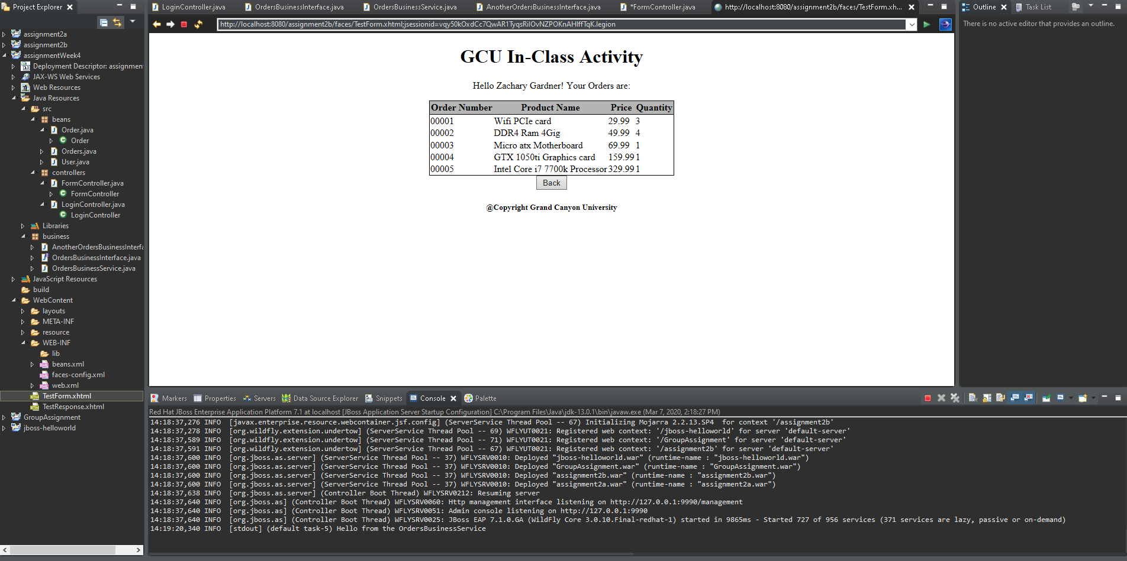

Test message for AnotherOrdersBusinessService

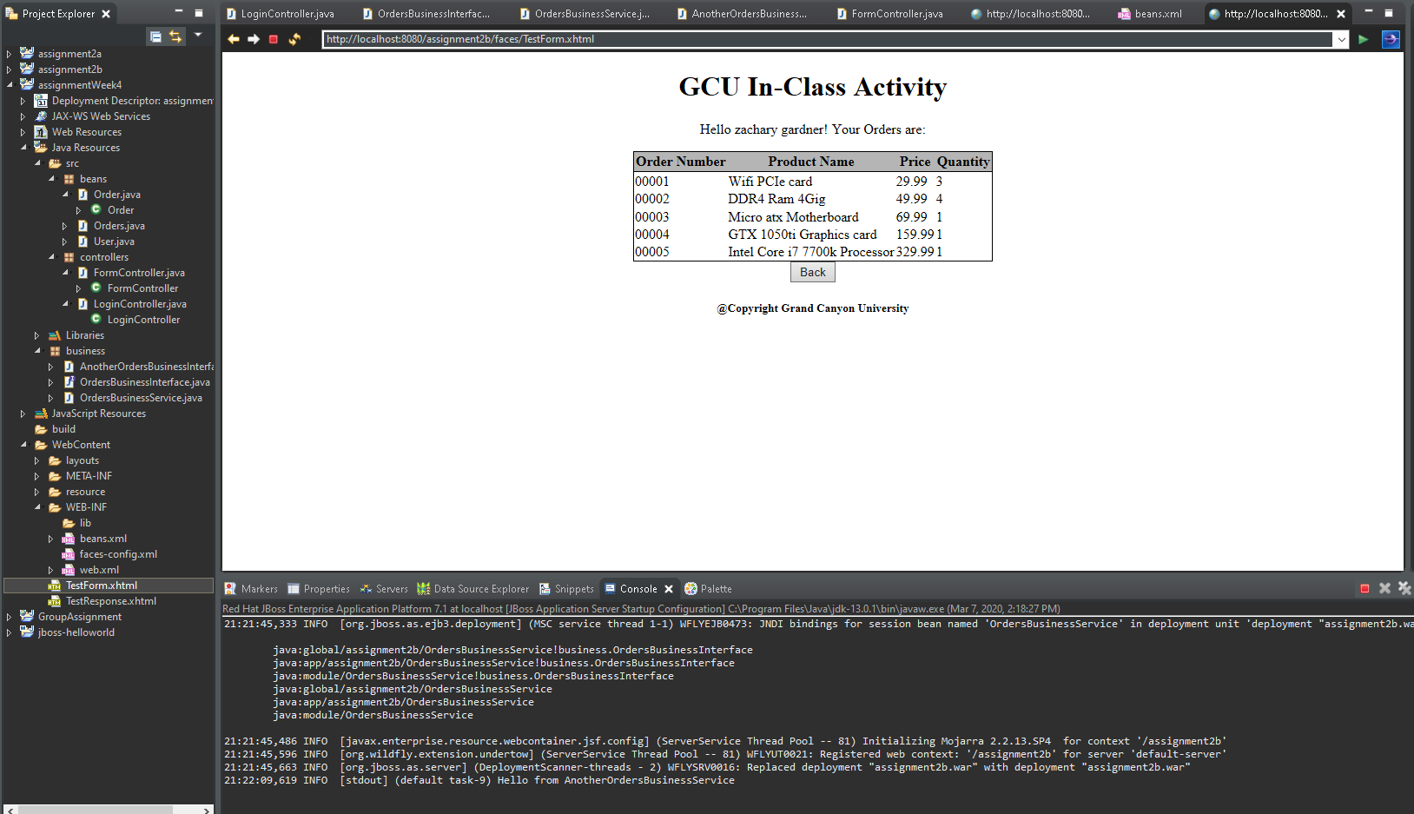

Orders list from AnotherOrdersBusinessService

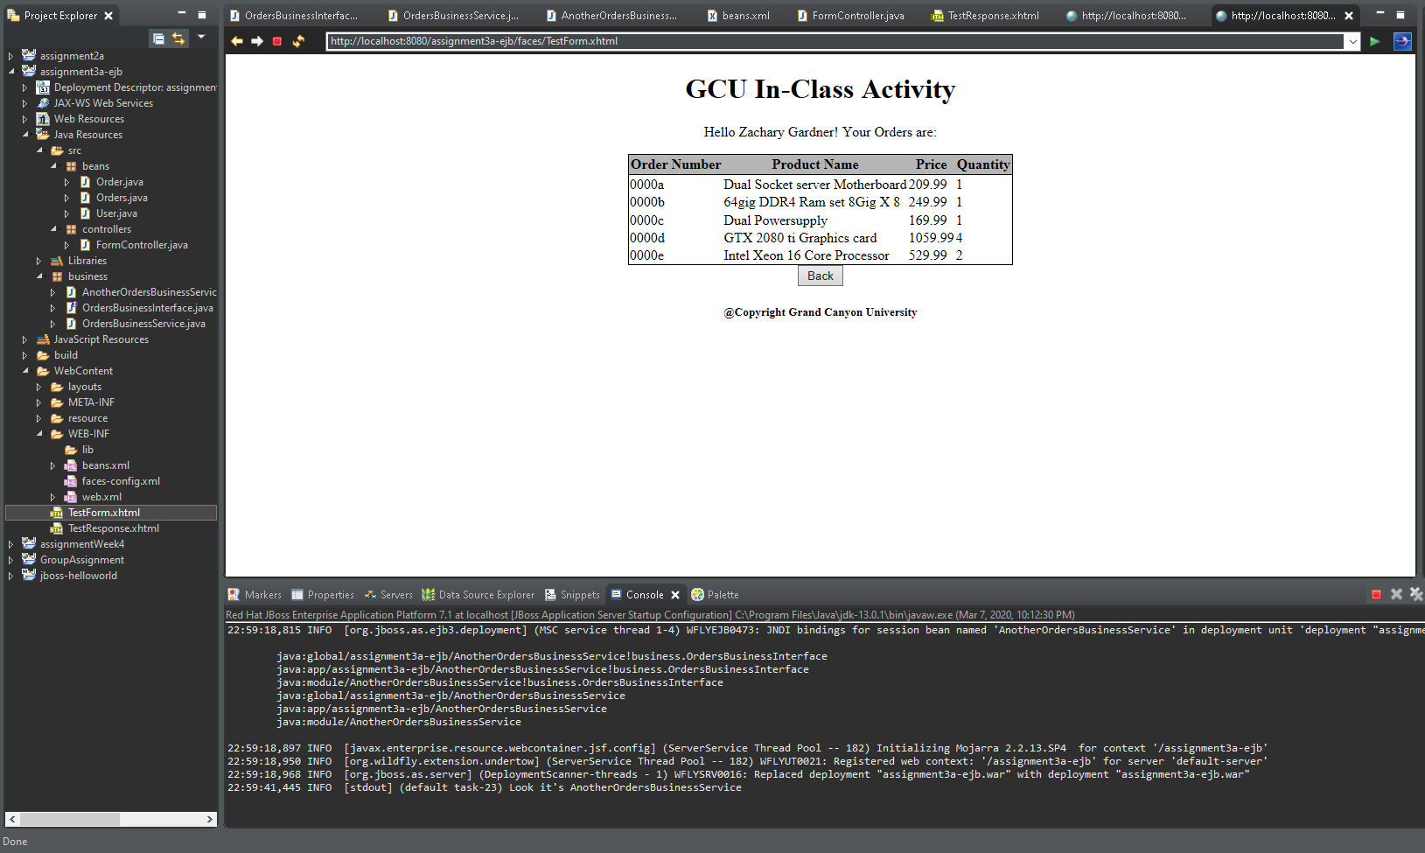

Orders list from OrdersBusinessService

